WORK & STUDY

Г. Сидней
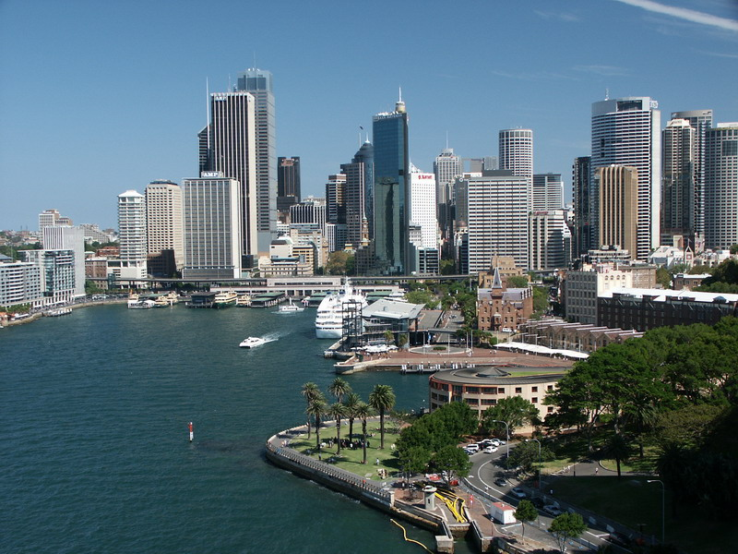
Обучение
и работа

Программа Работа и учеба в Австралии обеспечивает объем услуг, чтобы помочь зарубежным студентам с нахождением оплачиваемой работы в Сиднее.

Это – прекрасная возможность для любого, кто желает работать и учиться в Австралии.
Программа доступна для любого претендента, имеющего студенческую или рабочую визу.
Студенты ежедневно обучаются Интенсивному английскому языку в Языковом Центре Сиднея (Общий английский, Академический английский язык, Деловой английский, IELTS и Кембриджская подготовка), согласно расписания с понедельника по пятницу (8:30 – 12:50 или 8:30 – 14:30).
Студенты могут начинать курс английского в любой понедельник в течение года, с продолжительностью программы от 8 до 52 недель.
Программа включает помощь с составлением резюме, постановку на налоговый учет, получения разрешения на работу (для студентов, прибывших в Австралию по студенческой визе), предоставлении информации по работе в Австралии.
Студентам гарантируют до трех собеседований в отраслях промышленности, таких как гостеприимство, очистка, обслуживание клиентов, розничная продажа, торговля, услуги, и т.д. Собеседования будут проводиться в первые 8 недель после прибытия или когда уровень английского языка будет достаточным для возможности работать.
Средняя заработная плата составляет AU$12-18 в час.
Участвовать в программе могут:
Кандидаты, достигшие 18 летнего возраста, а так же, кто обладает, по крайней мере, достаточным для общения уровнем знания английского языка. Определение уровня знания английского языка происходит на основе собеседования.
Если уровень знания английского языка недостаточный, студенты обязаны будут пройти предварительный курс интенсивного общего английского языка, прежде чем претендовать на работу по данной программе.
Заявления на программу должны быть подаваться не менее чем за два месяца до начала программы, а так же студенты должны зарегистрироваться на программу не менее 8 недель для английского языкового курса в учебном центре.
Студентам, прибывшим в Австралию по Рабочей визе, разрешается обучение до 16 недель, и нет никаких ограничений на использование рабочего времени. Студенты, имеющие рабочую визу, должны будут обеспечить себя самостоятельно медицинской страховкой.
Обладатели Студенческой Визы могут участвовать в программе Работа & Учеба максимум до 52 недель, и они ограничены в работе до 20 часов в неделю.
Данные студенты должны зарегистрироваться в OSHC, обязательно иметь австралийскую студенческую медицинскую страховку. Важно, чтобы кандидаты на студенческую визу поняли то, что основная цель Студенческой Визы состоит в том, чтобы учиться, а не работать. Поэтому, работа, которую они получают, не может быть приоритетной над обучением.
Подбор работы происходит на основе заявок работодателей и способностей студента. Центр оказывает помощь в решении возникших проблем между работодателем и студентом.
Услуги учебного центра в получении направления на работу: 400$
В центре имеется возможность пройти подготовительные курсы по повышению квалификации, необходимой для получения более квалифицированной работы.

2013 COURSE SUMMARY
COURSE D E S C RIPTION LENGTH & DATES FEES TIMETABLE
GENERAL  ENGLISH  (GE) | BEST FOR EVERYDAY COMMUNICATION | 2-52  weeks | Students may  start on  any Monday  Term start:  2012-31-Dec  29-Jan  25-Feb  25-Mar  22-Apr  20-May  17-Jun  15-Jul  12-Aug  09-Sep  08-Oct  04-Nov  02-Dec  30-Dec | Super Intensive  (25 hrs/wk)  $340/wk  Intensive  (20 hrs/wk)  $300/wk  Mini Intensive  (15 hrs/wk)  Flat rate: $260/wk  (General English only | Enrolment  $220  Materials  2-8 wks:  $70  9-17 wks:  $140  18-30 wks:  $210  31+ wks:  $280 | SUPER INTENSIVE  25 HOURS FACE TO FACE  MONDAY TO FRIDAY
 | - Focus on everyday conversation and survival English  - Intensive Module Course for all English levels  - Six levels from Beginner to Advanced |  |  |  |  | 8:30am-9:30am  9:40am-11:10am  11:20am-12:50pm  * 1:30pm-2:30pm
ACADEMIC  ENGLISH  (AE) | BEST FOR FURTHER STUDY ARTICULATION
- Focus on Academic use of English
- Four levels from Pre-Intermediate to Advanced
- Qualify for direct entry into dozens of vocational courses, diplomas and degree programs
- Pre-enrolment test available
IELTS  PREPARATION  (IELTS) | BEST FOR IELTS EXAMINATION CANDIDATES | 4-36  weeks |  |  |  | INTENSIVE  20 HOURS FACE TO FACE  MONDAY TO FRIDAY
 | - Focus on English learning modes required for successful completion of the IELTS examination  - Reading, Writing, Speaking and Listening  - Lots of opportunities for practice tests  - Three levels from Intermediate to Advanced  - Pre-enrolment test available |  |  |  |  | 8:30am-9:30am  9:40am-11:10am  11:20am-12:50pm
BUSINESS  ENGLISH  (BE) | BEST FOR BUSINESS PROFESSIONALS | 4-15  weeks
 | - Focus on use of English in a business context  - Three levels from Intermediate to Advanced  - Pre-enrolment test available |  |  |  |  | MINI INTENSIVE  15 HOURS FACE TO FACE  MONDAY TO FRIDAY
CAMBRIDGE  PREPARATION  (FCE)  (CAE) | GLOBALLY RECOGNISED ENGLISH COURSE | 10-12  weeks | FCE & CAE  7/1 to 15/3  18/3 to 7/6  10/6 to 16/8  9/9 to 29/11 | Super Intensive (25hrs/wk):  $360/week  Intensive (20 hrs/wk):  $320/week  Enrolment Fee: $220  Materials Fee: $120  Examination Fee:  FCE $260 CAE $260 |  | (General English Only)  9:40am- 11:10am  11:20am-12:50pm  Student Visa holders are  not eligible for Mini Intensive
- English language certificate course developed by Cambridge University-recognised worldwide
- Lots of opportunities for practice tests
- Entry levels: Upper-Intermediate for FCE, Advanced for CAE
- Pre-enrolment test available
- Timetable suitable for Work & Study

MORNING CLASSES TOO EARLY? WORKING DURING THE DAY? ENJOY 20 HOURS FACE TO FACE TEACHING IN THE EVENING!
EVENING  CLASSES | - General English,  - IELTS Preparation  - Suitable for Student Visa Holders | 2-52  weeks | Same  as morning  courses | Intensive  (20 hrs/wk)  $250/wk | Same  as morning  courses | Monday to Friday  4:30pm - 5:50pm  6:00pm - 7:30pm  7:35pm - 8:45pm

Students may choose from electives including Conversation, Pronunciation, Grammar in Context, Writing Skills, Current Affairs and TOEIC preparation. Language Centre, Sydney is closed on Public Holidays 1/1, 28/1, 29/3, 1/4, 25/4, 10/6, 5/8, 7/10, 25/12 and 26/12. Substitute holiday to be considered by the Australian Government. All courses are offered subject to student numbers.
ENGLISH PLUS PROGRAMS
PROGRAM Program Description Length Program Fees
INTERNSHIP | - Participate in unpaid professional work experience placement in your chosen industry  - Entry level is Upper-Intermediate/Advanced - Pre-enrolment test available  - Full applications must be received 3 months in advance | 2-24  weeks | Internship Placement Fee:  2-6 weeks: $952, 7-12 weeks: $1248  13-24 weeks: $1536
WORK & STUDY | - This service helps you find paid work (cleaner, waiter, barista, bar staff etc) in Sydney  - Job Placement includes up to three interviews  - Entry level for Job Placement is Pre-Intermediate - Pre-enrolment test available  - Full applications must be received 2 months in advance, 8 wks min English course | 8-52  weeks | Work and Study  Job Placement Service: $400
DEMI PAIR | - Placement as a domestic assistant with a Sydney family  - Receive accommodation, meals and a weekly pocket allowance in exchange for approximately 20 hours child care and light housekeeping duties per week  - Entry level is Intermediate/Upper-Intermediate - Pre-enrolment test available  - Full applications must be received 3 months in advance | 12-52  weeks | Demi Pair Placement Fee: $300  Demi Pair Bond Deposit: $300  Homestay Deposit: $500
OCEANIA LINK | - Divide an English course between Language Centre in Sydney and Dominion in New Zealand  - Pay only one Enrolment fee and receive a free one-way airfare to or from New Zealand | 24-52  weeks | Contact us for further information  on available program packages
STUDY TOURS | - Available on request  - Please contact us | From  1week
ACCOMMODATION OPTIONS
Option | Accommodation Description |  | Fees
FAMILY  HOMESTAY | - Students are billeted with a family in Sydney (approximately 30-50 minutes away from the school)  - An excellent way to improve your English and learn about Australian lifestyle and culture  - Friendly and safe family environment - ideal for students with limited travelling experience  - Available as Single Room or Twin Share (must be booked by two students travelling together)  - With meals (breakfast and dinner Mon-Fri and all meals on weekends) or room only (Single only)  - Many Australian families keep pets so this may not be the best option for students with allergies  - Families are not obliged to provide Internet access.  - 2 weeks minimum stay |  | Placement Fee: $200  Single Room:  With meals: $250/week  Room only: $190/week  Twin Share:  With meals: $220/week  Daily Rates:  $40/night, $31/night, $36/night
STUDENT  HOSTEL | - Live with other international students and travellers in a vibrant communal environment  - Suitable for more independent students or those with more travel experience  - Convenient Sydney City locations allows students to save on travelling expenses to and from Access  - 24 hour a day access - suitable for students with part-time after hours jobs with late finishing times  - Single or shared rooms available  - Shared bathroom and kitchen facilities |  | Placement Fee: $200  Single Room:  From $315/week  Twin Share:  From $217/week  Bond: $150 (on arrival)  (Price per person)
STUDENT  GUESTHOUSE/  RESIDENCE | - Suitable for students seeking more luxury/comfort than hostels offer  - Convenient Sydney City locations allows students to save on travelling expenses to and from Access  - Wonderful way to meet new friends  - Wide range of guesthouse options, each with their own charming characteristics  - Available as Single, Double or Triple Room  - All types of rooms have Internet access and TV  - 24 hour a day access with a live-in Manager  - 4 weeks minimum stay |  | Placement Fee: $200  Single Room:  From $275/week  Double Room:  From $185/week  Triple Room:  From $150/week  (Price per person)
Accommodation is subject to availability In the event that students request a change in accommodation after placement, an Accommodation Change Fee of $100 will apply

OTHER FEES & CHARGES
AIRPORT MEETING SERVICE | - Greeting at Sydney airport and delivery to your accommodation  - All inclusive price - no additional fees | Arrival: $110  Departure: $70
OVERSEAS STUDENT  HEALTH COVER | - Student Visa Holders must have Overseas Student Health Cover (OSHC)  - Language Centre, Sydney can arrange this for you or you can organize your own  - Only applies to Student Visa holders | Single: $41.50/month  Couple:$86.75/month  Family: $146/month
LIVING IN SYDNEY
TRANSPORT | - Students in Homestay Accommodation should allow around $45 per week for transport to and from Language Centre Monday to Friday  - Overseas students do not qualify for student concession fares on public transport in NSW
MEALS | - Students should allow around $8 -12 per day for lunch  - Students cooking their own meals should allow around $120 per week for food
RECREATION | - Students should allow around $100 per week for recreation and entertainment such as trips to the movies etc  - Language Centre organises up to three extra curricular excursions each week to popular tourist attractions in Sydney
INSURANCE | Language Centre strongly recommends that students take out insurance on their possessions  We strongly recommend that Tourist and Working Holiday Visa holders take out health insurance for the duration on their stay
SCHOOL AGE  DEPENDENTS | It is Australian law that students travelling with school age dependents must pay full fees for their primary and secondary education if these dependents attend Australian schools
CLIMATE | Summer (December to February) 27 C - 30 C Autumn (March to May) 11 C - 24 C  Winter (June to August) 5 C - 17 C Spring (September to November) 11 C - 24 C

